Darren Sheftic

CS 330 – Cmp Grph & Vis

Module Two Milestone

1/19/2024

* **Select a 2D image to recreate as a 3D scene**. It is recommended that you take your own photo because this will allow you to investigate the different perspectives of the objects in your scene. It will benefit you to have multiple images of different angles of the 2D scene for reference. However, while you may take your own photos, you are also welcome to instead create a sketch or find an image online that you wish to model. You will need to have *four* objects in your scene. At least one of these objects needs to be made of two or more primitive shapes. You will need to use at least *four* different primitive shapes in your work. Note that your options for shapes to incorporate into your scene are listed below.
* Cube
* Cylinder
* Plane
* Pyramid
* Sphere
* Torus
* 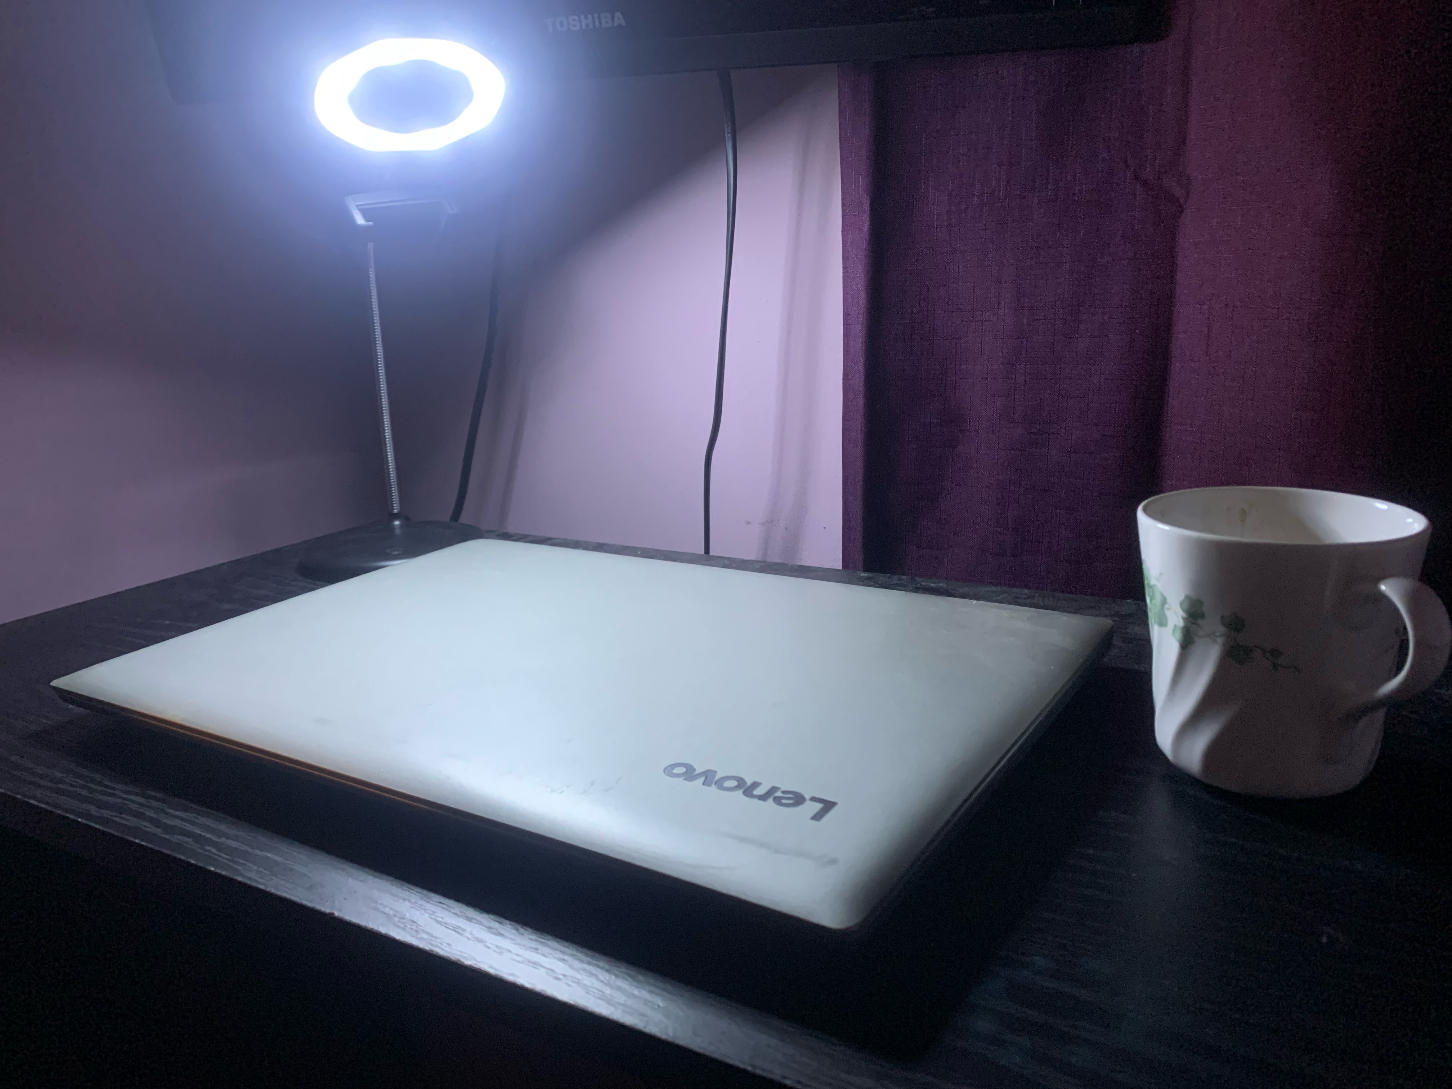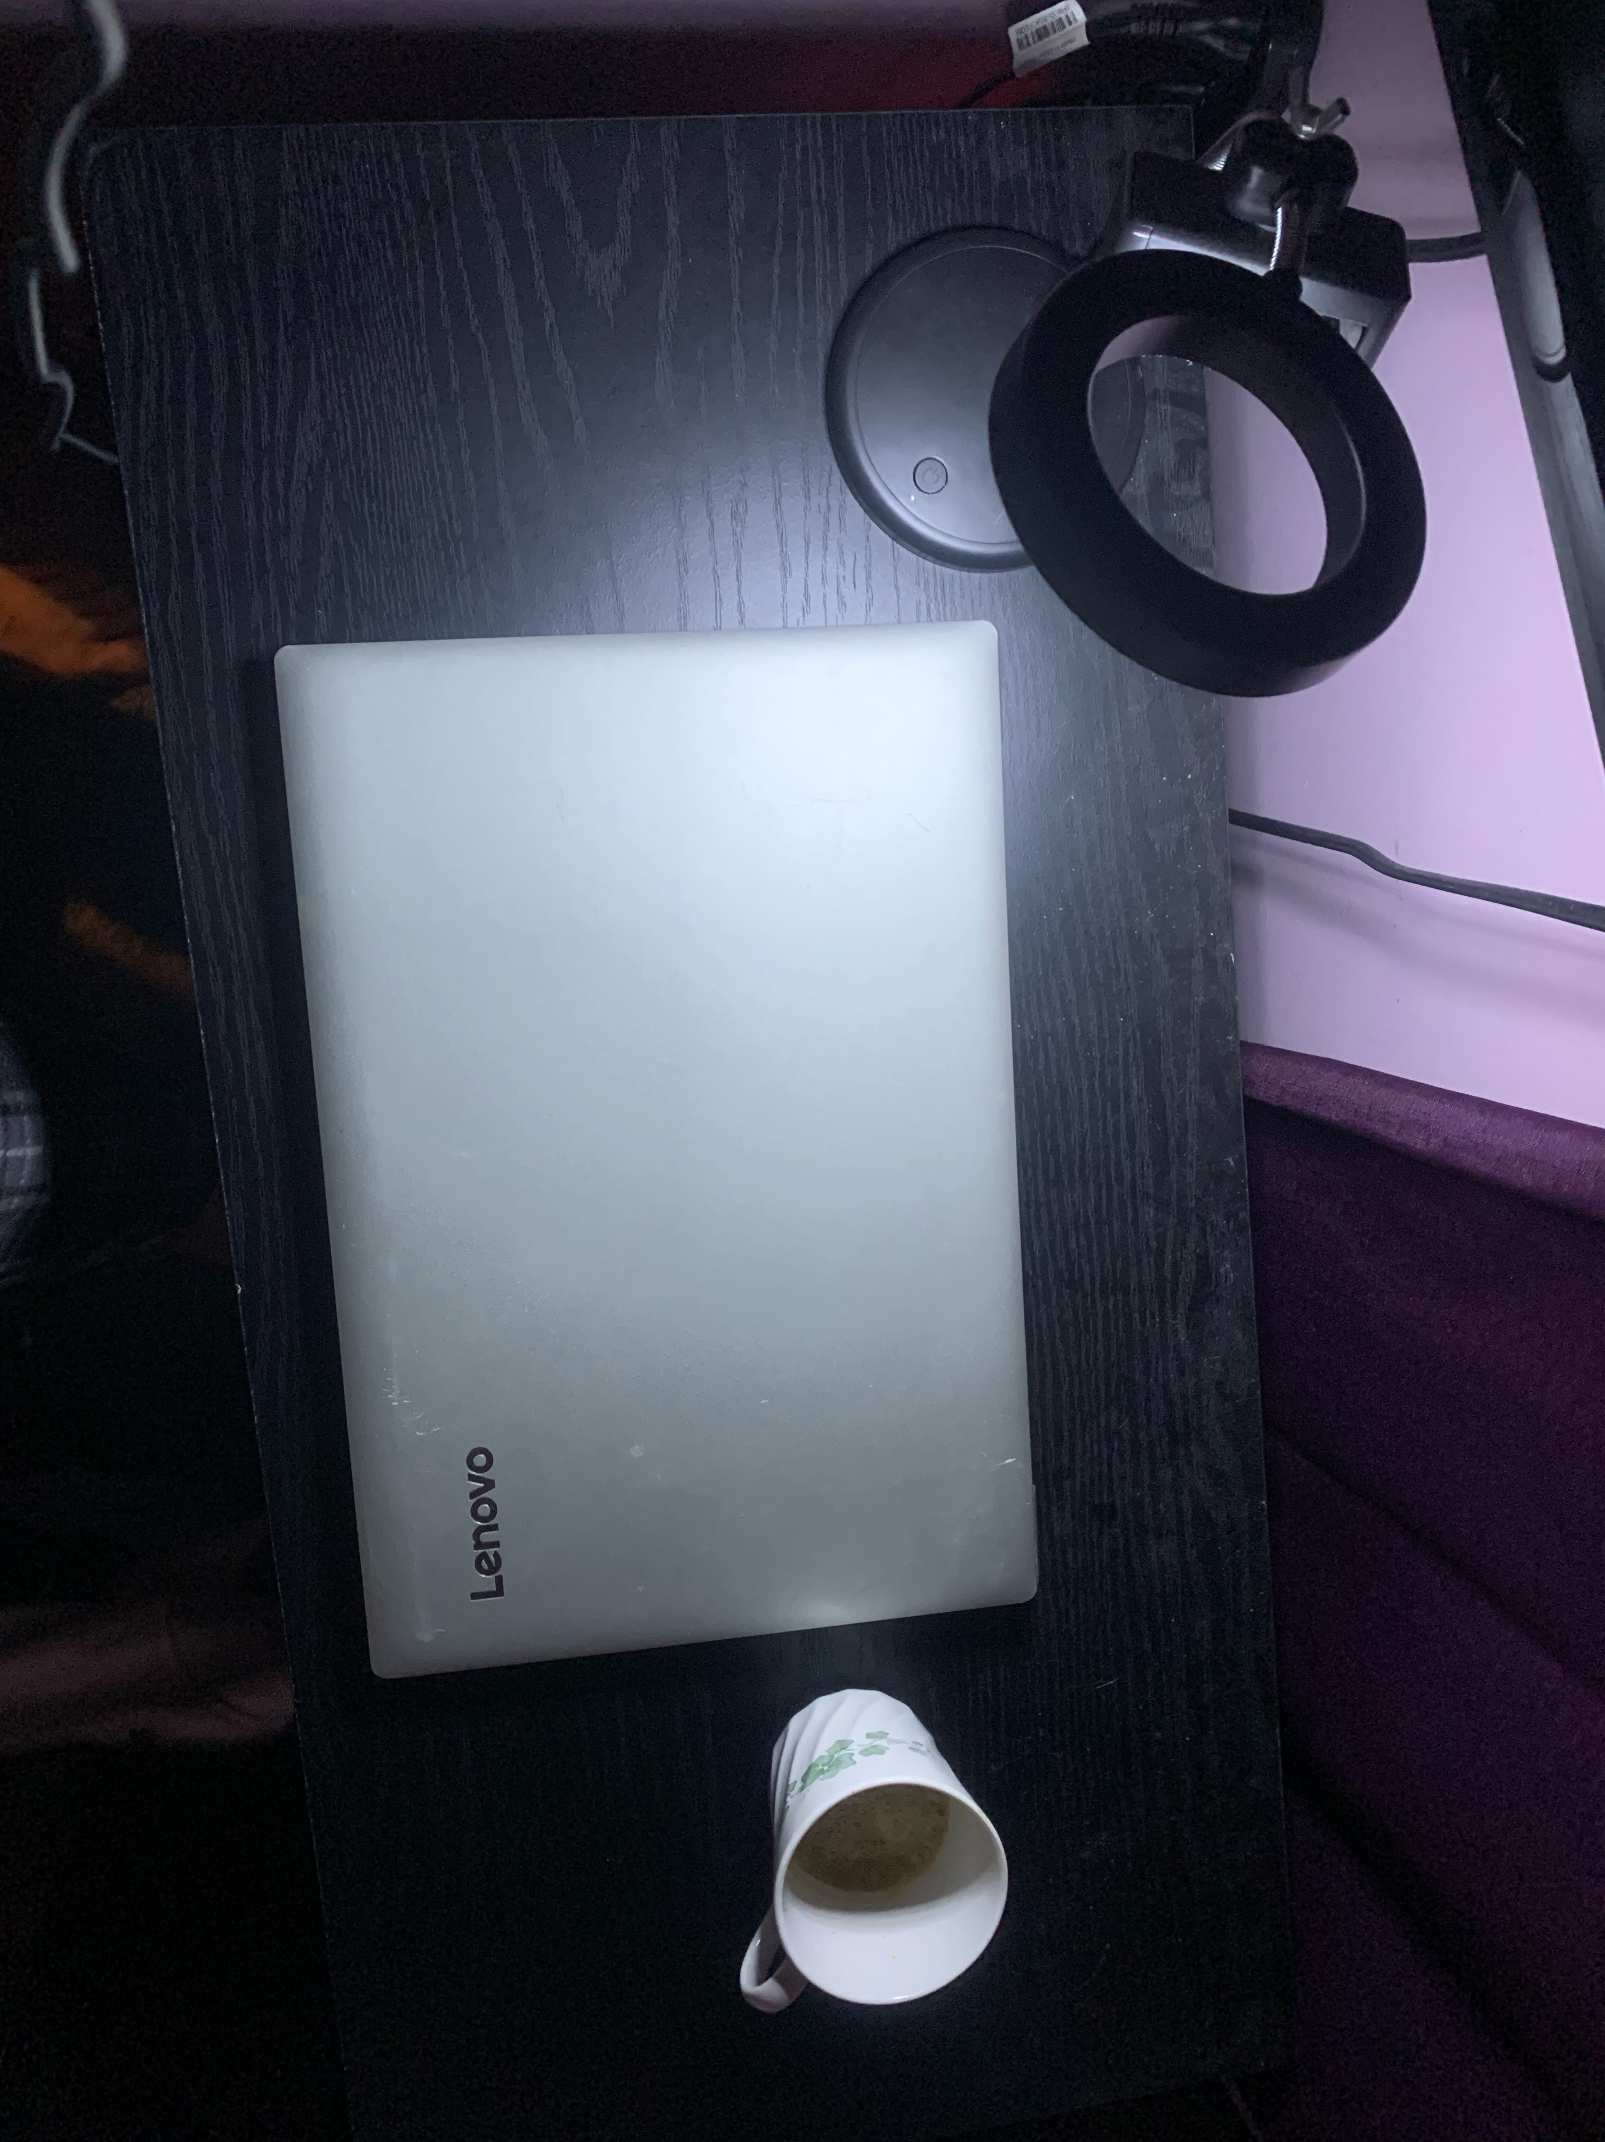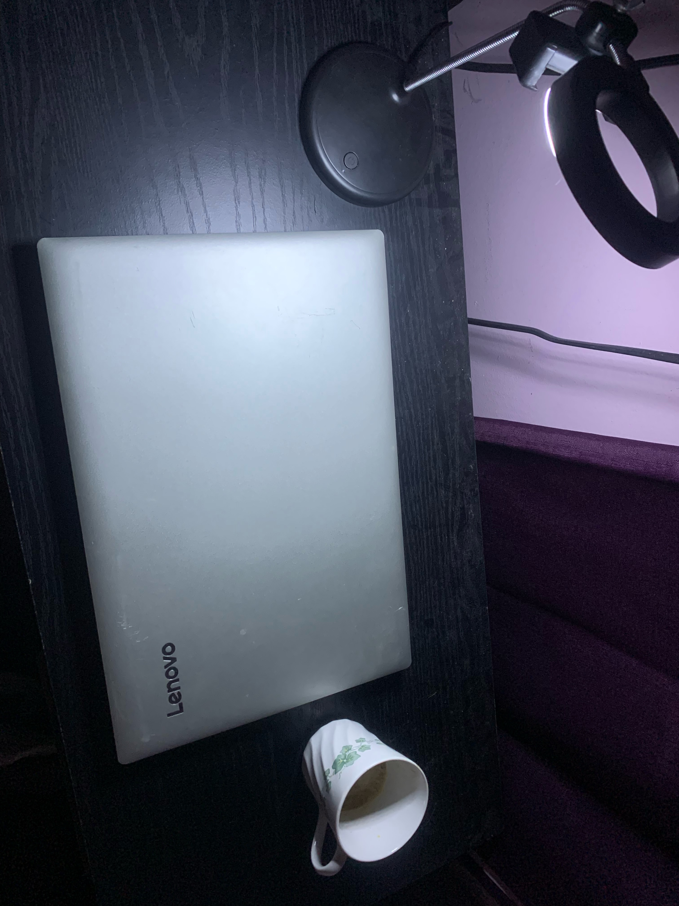
* **Discuss which objects will be created in 3D**. Of the items included in your image, select which ones you will be creating in 3D. Then explain why these are a good choice for your work.
* **Explain which primitive shapes will be used to create 3D representations of the 2D objects**. Break each of the objects you have identified down into their component shapes. Be sure to include a plane, which will be used to ground the rest of the objects, in your scene. For example, in one of this week’s videos you saw how the flat surface of a desk that held multiple objects could be represented as a plane. As you work, explain why your choices make sense and how you will be able to accomplish the overall scope of the work. The goal is to ensure the selections you make will be exciting to explore but also achievable.

The desk will serve as a **plane**, the cup can be either a reversed **cone** or a **cylinder**, the laptop can be a **cube**, and the ring light can serve as both a **light source, torus, and cyclinder**. To simplify the ring light I will be removing the phone holder grip. These items will be simple and fun to recreate without being too difficult for a beginner. My room has a lot of monochrome colors so I’ll likely be using the color of the wall behind the desk as well as try to get a texture for the cup the matches the green leaves. The cup will probably be the most difficult part with needing to texture it.